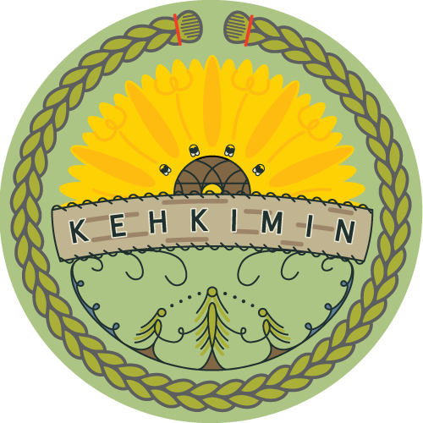

Job Posting

Nutokehkikemicik (Teachers)

Kehkimin is looking for two full-time teachers to launch the first Wolastoqey immersion land-based School. The first year will start on August 29, 2022, for teachers, and on September 6, 2022, for students. There will be a Wolastoqey language camp from June 23-27, 2022, and it will be required for each applicant to attend at least some of this camp. The school is located on the northside of Fredericton (Killarney Lodge).
Requirement/Skills include:
- the ability to understand and speak Wolsatoqey at a basic level (K4-5) and be willing to advance in ongoing learning
- has successfully graduated from the two-year Wolastoqey Intensive language program or possesses equivalent knowledge and experience
- possesses an Early Childhood Education certificate/diploma or is currently enrolled in a ECE program or is willing to enroll in a ECE program (within the first year of employment)
- certified as a land-based educator or experience teaching in a land-based environment preferable
- experience in teaching and/or teaching in Wolastoqey language preferable
Need to provide evidence of the following prior to teaching children:
- a criminal record check/vulnerable sector check
- a 16-hour Standard First Aid with CPR Level C certificate issued from a recognized provider such as Workplace Standard First Aid and CPR Level C or Standard Childcare First Aid and CPR Level C
Needed for application:
- Send resume to Kehkiminlang@gmail.com
- Three references (from work experience and not persons related to you)

