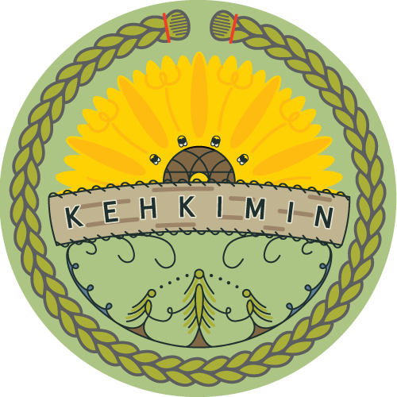

Kehkimin
Application Form

Student Name:

Date of Birth:

Community Affiliation:

Tell us why you are interested in having your child attend our program:

Contact information:

Phone:

e-mail:

Please send application form to Kehkiminlang@gmail.com
Application deadline: July 15, 2022

